Analysis Artifacts for Use Case 06 – Manage Providers

**Table Of Contents**

Build ERD **2**

2. Robustness Diagram **3**

3. Class Diagram **4**

4. Sequence Diagram **5**

5. Communication Diagram **8**

**Add provider:** **8**

6. State Diagram: Created By Tejaswi Dasyam **9**

7. Data Flow Diagram **9**

8. Interface: Created By Tejaswi Dasyam **11**

# 

# Build ERD



# 2. Robustness Diagram



# 3. Class Diagram

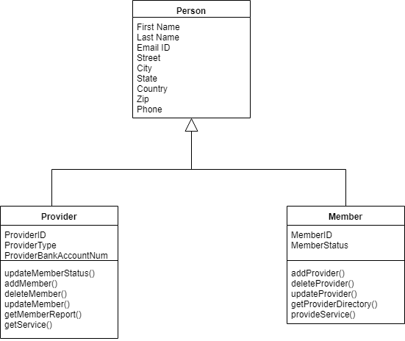

# 

# 

# 4. Sequence Diagram

Add Provider:



Delete Provider:



Update Provider



# 5. Communication Diagram

# Add provider:



Delete Provider:



Update Provider:



# 6. State Diagram: Created By Tejaswi Dasyam

Provider State:



# 7. Data Flow Diagram



# 8. Interface: Created By Tejaswi Dasyam

Main Screen

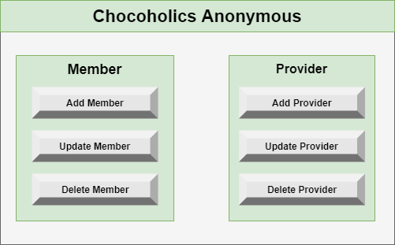

External Interface

